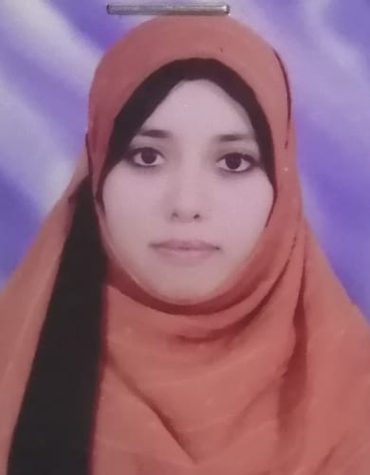
C.V.

Name:
Doaa Mokhtar Mahmoud Mohammed

Personal data:
- Date of birth: 15/5/1986.

- Marital status: Married.

- Nationality: Egyptian.

- Address: 29 Sherket kolta infront of El-Rahma school, Assiut.

- Phone number:01005308849.

- E – Mail address: Doaamokhtarmahmoud@gmail.com.

Education:
- Master’s degree in neuropsychiatry, faculty of medicine, Assiut University, 2014.
- General grade: Very good.

- Bachelor Degree in Medicine and Surgery, faculty of medicine, Assiut University, 2009.
- General grade: Excellence with Honor.

Experience:

- Assistant lecturer in Neuropsychiatry department, Assiut University Hospitals (April 2014 till now).

- Resident doctor in Neuropsychiatry department, Assuit University Hospitals (2011 – 2014).

- Internship year rotations at Assiut University Hospital (March 2010 - Feb 2011).

Publications:

Construction of standardized Arabic questionnaires for screening neurological disorders (dementia, stroke, epilepsy, movement disorders, muscle and neuromuscular junction disorders).
Published in the Neuropsychiatric disease and treatment journal, 2016.

Skills:

- Cooperative, flexible, decision making skills, friendly with patient, problem solving Skills, ability to work under pressure and to do team work and self-confidence.

Languages:
- Arabic: mother tongue excellent.

- English: second language, very good speaking, reading and writing, passed TOEFL exam.

Computer skills:

- Good experience in dealing with Microsoft office (word, excel, power point), internet search and browsing.

- Good experience in dealing with SPSS program.

References:
- Available on request.

